**VISVESVARAYA TECHNOLOGICAL UNIVERSITY**

**“Jnana Sangama”, Belagavi-560018, Karnataka**

**DATABASE MANAGEMENT SYSTEMS LABORATORY**

**WITH MINI PROJECT- 19IS5DLDBM**

**REPORT**

**On**

**“Courier Management”**

**BACHELOR OF ENGINEERING**

**In**

**INFORMATION SCIENCE AND ENGINEERING**

**Submitted by**

**Pankaj Garg [1DS19IS066]**

**Saquib Ameer Khan [1DS19IS089]**

**LAB IN-CHARGE**

Mrs. Bhavani K

Dr. Rashmi S



**2021-22**

**Department of Information Science and Engineering**

**DAYANANDA SAGAR COLLEGE OF ENGINEERING**

**SHAVIGE MALLESHWARA HILLS, KUMARASWAMY LAYOUT**

**Bengaluru-560078**

**DAYANANDA SAGAR COLLEGE OF ENGINEERING**

Shavige Malleshwara Hills, Kumaraswamy Layout-560078

**Department of Information Science and Engineering**



**2021-22**

**CERTIFICATE**

This is to certify that Database Management Systems Laboratory with Mini Project Work (19IS5DLDBM) entitled “**Courier Management**” is a bonafide work carried out by **Pankaj Garg [1DS19IS066]** and **Saquib Ameer Khan [1DS19IS089]** in the partial fulfillment for the 5th semester of Bachelor of Engineering in Information Science and Engineering of the Visvesvaraya Technological University, Belgavi during the year 2020-21.

**Signature of Lab-Incharge**

**Name of the Examiners Signature with Date**

**1._____________________ ___________________**

**2._____________________ ___________________**

**S**

**ACKNOWLEDGEMENT**

It is a great pleasure for us to acknowledge the assistance and support of a large number of individuals who have been responsible for the successful completion of this project.

We take this opportunity to express our sincere gratitude to **Dayananda Sagar College of Engineering** for having provided us with a great opportunity to pursue our Bachelor Degree in this institution.

In particular we would like to thank **Dr. C. P. S Prakash**, Principal, Dayananda Sagar College of Engineering for his constant encouragement and advice.

Special thanks to **Dr. Udaya Kumar Reddy K R**, HOD &amp; Vice Principal, Department of Information Science &amp; Engineering, Dayananda Sagar College of Engineering for his motivation and invaluable support through the development of this project.

We are highly indebted to our internal guide **Mrs. Bhavani K & Rashmi S**, Asst. Professor, Department of Information Science &amp; Engineering, Dayananda Sagar College of Engineering for their constant support and guidance. They have been a great source of support throughout the course of this project.

Finally, we gratefully acknowledge the support of our families during the completion of the project.

**Pankaj Garg 1DS19IS066**

**Saquib Ameer Khan 1DS19IS089**

**ABSTRACT**

This Courier Database Management System Project will have different modules. The login section will have a login facility for the admin and for the user who will operate this system. While taking orders from its customers, it will take all the details of its customers who are placing the orders and all the details for the recipient such as its address, name, mobile number. Through the tracking id, customers or its recipient will be able to track their products from any location using the internet. It will provide status of the product after placing orders within 1 minute.

The admin can manipulate the data through the admin login page and add any new consignment if required. The profile section shows the data of the user and the ricing section of the project shows the price that will be charged for the consignment according to the weight categories.

Using the courier service, a person can easily send his/her parcel to another person in the particular destination within the time.

[Ecommerce is growing](https://www.statista.com/statistics/379046/worldwide-retail-e-commerce-sales/) at a rapid pace, and it’s making parcel delivery a major concern for companies of all sizes. Large corporations and small businesses alike are wading into the waters of [in-house delivery](https://optimoroute.com/in-house-delivery/) to reduce shipping costs and maintain control over their customer experience.

In-house courier delivery can be extremely beneficial if you do it well. You’d be hard-pressed to find a third-party courier service that cares more about your products and your customers than you do.

A courier management system is business software that simplifies courier management and routing.

**CONTENTS**

| **Chapter** | **Title** | **Page number** |
| --- | --- | --- |
| 1 | Introduction   * Objective * Problem statement * Scope * Motivation * Features | 5 |
| 2 | Requirement   * Functional * Non-functional * System requirement | 8 |
| 3 | ER Diagram | 10 |
| 4 | Schema Diagram | 13 |
| 5 | System Design   * Table description | 15 |
| 6 | Normalization   * 1NF * 2NF * 3NF | 18 |
| 7 | Implementation   * Functional module * Framework | 19 |
| 8 | Stored procedure | 21 |
| 9 | Triggers | 22 |
| 10 | Code Segment | 23 |
| 11 | Snapshots | 24 |
| 12 | Conclusion   * Conclusion * Future scope * Report generation | 30 |
| 13 | Reference   * Book * Website | 33 |

**Chapter 1**

**Introduction**

This Courier Management System Project will have different modules. The login section will have a login facility for the admin and for the user who will operate this system. While taking orders from its customers, it will take all the details of its customers who are placing the orders and all the details for the recipient such as its address, name, mobile number.

During the billing process the system will generate a tracking id for their products. Through this tracking id, customers or its recipient will be able to track their products from any location using the internet. It will provide status of the product after placing orders within 1 minute.

The courier service is one of the solutions to these problems. It is used to send some things to any person in the world within time. The courier company has a number of branches, which are spread over the country or the world.

So that when a person wants to send things then he has to contact the nearest courier service branch. The courier company creates the schedule & gives internal/external services. The courier service works as a destination office or source office.

In the modern age, as time increases, needs & requirements of the person are also increased. They want more facilities & try to do their task quickly & within time. But they can not get all the things at the nearest market or area, so they have to import the things from any place in the world.

Within the country, the things can be imported through post service. But it consumes the time & sometimes problems of damage or missing occur. Whereas in the international market, the one way is shipping. But it also requires more time.

#### **1.1 Objective**

The main objective of this project is to determine how an interactive inventory management system helps in the smooth functioning of a warehouse compared to traditional inventory management, by digitizing all the records and transacting everything on a computer rather than on paper. This project is a two-tier architecture application.

#### **1.2** **Problem Statement**

Existing systems for Warehouse Inventory Management are very inefficient and mostly involve a lot of manual work to be done by the manager of the system. With this project, we want to automate as many tasks as possible using the available technology and the internet.

#### **1.3** **Scope of the report**

The essential framework of this report would be to elaborate the design of E.R-diagram, Schema Diagram and to display how the modules of the program work in order to achieve the automation.

**1.4 Motivation behind this project:**

To gain the maximum business region, customers demand good service. So to make more profit and gain maximum business profit, their administration must also have a system to tackle all these problems on time. Its administration can take immediate orders and provide a receipt which will include all the details of the products along with appropriate price to their customers. Thus saving time and eliminating line making processes.

**1.5 Features of Proposed System:**

These are the important features of the project Courier Management System:

* In the computer system of the courier service computation of the rate is easily & quickly done.
* Computer system of the courier service provides fast access.
* Using this computerized system, bill issued procedure becomes fast.
* In the computer system the person has to fill the various forms & number of copies of the forms can be easily generated at a time.
* In the computer system, it is not necessary to create the Manifest but we can directly print it,which saves our time.
* It contains better storage capacity.
* Accuracy in work.
* Easy & fast retrieval of information.
* Well designed reports.
* Decrease the load of the person involved in the existing manual system.
* Access of any information individually.
* Work becomes very speedy.
* Easy to update information.

#### 

**Chapter 2**

**SYSTEM AND SOFTWARE REQUIREMENTS AND SPECIFICATIONS**

The program works on Desktop PC and is executed using a PHP 5 interface which interacts with a MySQL database running on localhost.

**2.1 FUNCTIONAL REQUIREMENTS**

A description of the facility or feature required. Functional requirements deal with what the system should do or provide for users. They include description of the required functions, outlines of associated reports or online queries, and details of data to be held in the system.

**2.1.1 Interface Requirements**:

* The system shall provide an option to add/delete quizzes with questions.
* The system shall provide an option to see and attend the quizzes.
* The system should give the option for login for staff and students.
* The system shall provide an option to see scores.

**2.2 NON-FUNCTIONAL REQUIREMENTS:**

Non-functional requirements define the overall qualities or attributes of the resulting system.

**2.2.1 Usability**

Usability is the ease with which a user can learn to operate the online examination system and get results.

**2.2.2 Security**

Security requirements are included in a system to ensure:

* All questions and users are well secured
* SQL injection is prevented

**2.2.3 Reliability**

Reliability is the ability of a system to perform its required functions under stated conditions for a specific period of time. Constraints on the run-time behavior of the system can be considered under two separate headings:

* Availability: is the system available for service when requested by end-users.
* Failure rate: how often does the system fail to deliver the service as expected by end- users.

**2.3 System Requirements:**

**2.3.1 Software Requirement:**

* Apache Server 2.0
* PHP Version 5.3 or above
* MySQL Version 5.5 or above
* Latest browser : Chrome, Firefox, Safari etc
* Operating System : Any (Linux**,** Windows, Mac etc)

**2.3.2 Hardware Requirements:**

* Processor Pentium IV or higher version.
* Ram 128 MB or above
* Hard Disk 150 MB or above

**Chapter 3**

**ER DIAGRAM**

This chapter of the report describes the structure of the project, followed by Entity Relationship Diagram, Schema Diagram and the table structures.

**3.1 ER Diagram with relationships and cardinality ratio**

An entity relationship model, also called an entity-relationship (ER) diagram, is a graphical representation of entities and their relationships to each other, typically used in computing in regard to the organization of data within databases or information systems. An entity is a piece of data-an object or concept about which data is stored.

The cardinality or fundamental principle of one data aspect with respect to another is a critical feature. The relationship of one to the other must be precise and exact between each other in order to explain how each aspect links together. In simple words Cardinality is a way to define the relationship between two entities.

The following are the notations of the ER diagram:

The geometric shapes and their meaning in an E-R Diagram. We will discuss these terms in detail in the next section(Components of an ER Diagram) of this guide so don’t worry too much about these terms now, just go through them once.

* **Rectangle**: Represents Entity sets.
* **Ellipses**: Attributes
* **Diamonds**: Relationship Set
* **Lines**: They link attributes to Entity Sets and Entity sets to Relationship Set
* **Double Ellipses:** Multivalued Attributes
* **Dashed Ellipses**: Derived Attributes
* **Double Rectangles**: Weak Entity Sets
* **Double Lines**: Total participation of an entity in a relationship set

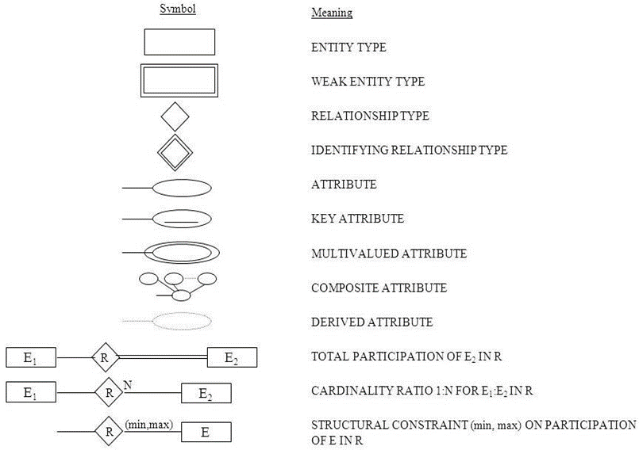

**Fig 3.1: Notations for ER Diagrams**

The ER diagram below shows the relationship between the many tables that exist in the database for the functioning of Warehouse Inventory Management System.

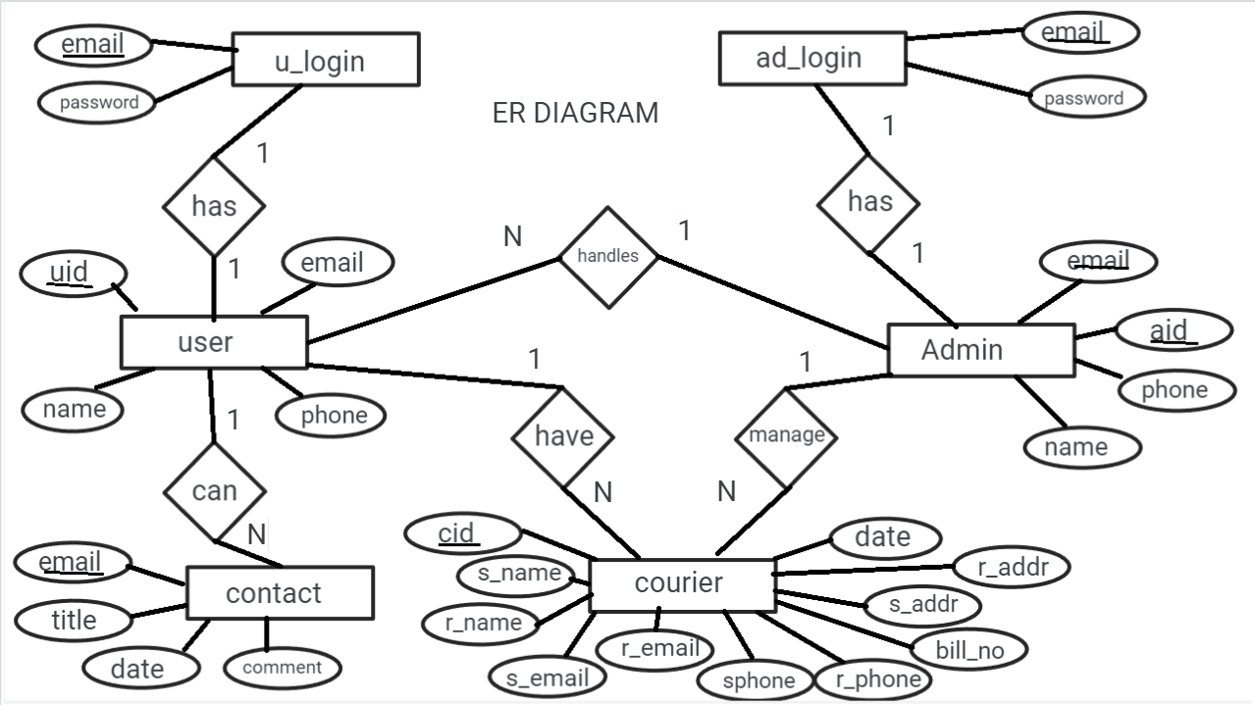

**Fig 3.2: ER Diagram of Courier Management System**

**Chapter 4**

**Schema Diagram**

In any data model it is important to distinguish between the description of the database and the database itself. The description of a database is called the database schema, which is specified during database design and is not expected to change frequently.

A displayed schema is called a schema diagram. A schema diagram displays only some aspects of a schema, such as the names of record types and data items, and some types of constraints.

A database schema is the skeleton structure that represents the logical view of the entire database. It defines how the data is organized and how the relations among them are associated. It formulates all the constraints that are to be applied on the data.

**4.1 ER-to-Relational Mapping Algorithm**

* Step 1: Mapping of Regular Entity Types
* Step 2: Mapping of Weak Entity Types
* Step 3: Mapping of Binary 1:1 Relation Types
* Step 4: Mapping of Binary 1:N Relationship Types.
* Step 5: Mapping of Binary M:N Relationship Types.
* Step 6: Mapping of Multivalued attributes.
* Step 7: Mapping of N-ary Relationship Types.

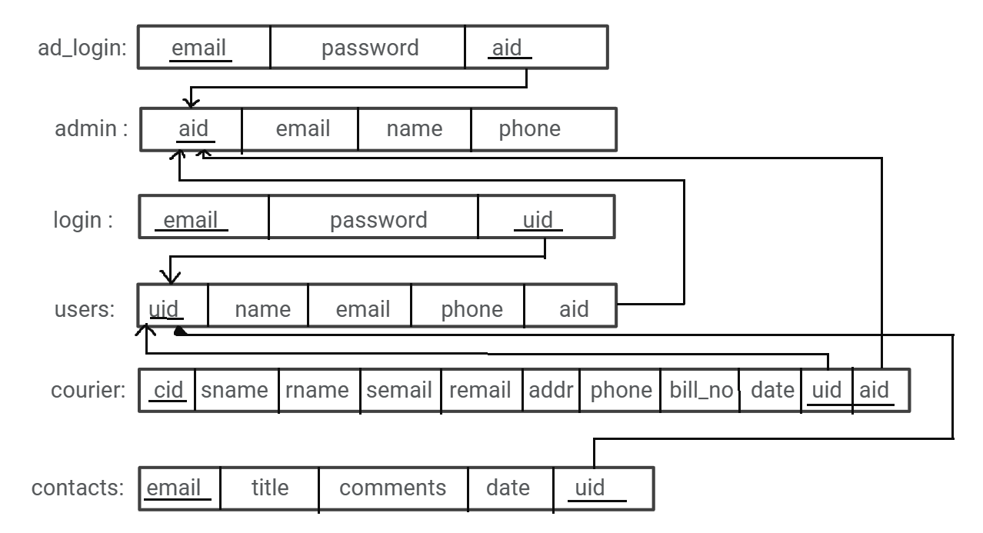

**Fig 4.2: Schema Diagram**

**Chapter 5**

**System Design**

**5.1 Table Description**

**5.1.1 AD-Login**

|  | **Name** | **Types** |
| --- | --- | --- |
| 1 | Email | varchar(50) |
| 2 | Password | varchar(50) |
| 3 | a_id (PK) (FK) | int(11) |

**5.1.2 Admin**

|  | **Name** | **Type** |
| --- | --- | --- |
| 1 | a_id (PK) | int(11) |
| 2 | Email | varchar(50) |
| 3 | Name | varchar(50) |
| 4 | p_number | int(14) |

**5.1.3 Contacts**

|  | **Name** | **Type** |
| --- | --- | --- |
| 1 | Id (PK) (FK) | int(11) |
| 2 | Email (PK) | varchar(30) |
| 3 | subject | varchar(50) |

**5.1.4 Login**

|  | **Name** | **Type** |
| --- | --- | --- |
| **1** | Email (PK) | varchar(50) |
| **2** | password | varchar(50) |
| **3** | u_id (PK) (FK) | int(11) |

**5.1.5 Users**

|  | **Name** | **Type** |
| --- | --- | --- |
| 1 | u_id (PK) | int(11) |
| 2 | email | varchar(50) |
| 3 | name | varchar(50) |
| 4 | p_number | int(14) |

**5.1.6 Courier**

|  | **Name** | **Type** |
| --- | --- | --- |
| 1 | c_id (PK) | int(11) |
| 2 | u_id (PK) (FK) | int(11) |
| 3 | s_email | varchar(50) |
| 4 | r_email | varchar(50) |
| 5 | s_name | varchar(50) |
| 6 | r_name | varchar(50) |
| 7 | s_phone | varchar(20) |
| 8 | r_phone | varchar(20) |
| 9 | s_addr | varchar(50) |
| 10 | r_addr | varchar(50) |
| 11 | weight | int(11) |
| 12 | Bill_no | int(11) |
| 13 | date | date |
| 14 | Image | blob |

**Chapter 6**

**Normalization**

Normalization is the process of minimizing redundancy from a relation or set of relations. Redundancy in relation may cause insertion, deletion, and update anomalies. So, it helps to minimize the redundancy in relations. Normal forms are used to eliminate or reduce redundancy in database tables.

**6.1 First Normal Form**

If a relation contains a composite or multi-valued attribute, it violates the first normal form or a relation is in the first normal form if it does not contain any composite or multi-valued attribute. A relation is in first normal form if every attribute in that relation is a single valued attribute.

**6.2 Second Normal Form**

To be in second normal form, a relation must be in first normal form and relation must not contain any partial dependency. A relation is in 2NF if it has No Partial Dependency, i.e., no non-prime attribute (attributes which are not part of any candidate key) is dependent on any proper subset of any candidate key of the table.

Partial Dependency – If the proper subset of a candidate key determines non-prime attributes, it is called partial dependency.

**6.3 Third Normal Form**

A relation is in third normal form, if there is no transitive dependency for non-prime attributes as well as it is in second normal form.

A relation is in 3NF if at least one of the following condition holds in every non-trivial functional dependency X –> Y

X is a super key.

Y is a prime attribute (each element of Y is part of some candidate key). Transitive dependency – If A->B and B->C are two FDs then A->C is called transitive dependency.

**Chapter 7**

**IMPLEMENTATIONS**

#### **7.1 Functional Modules**

The functional modules included in the project are listed below:

#### **7.1.1 Insert Module:**

This module provides the functionality of collecting the required data from the designed interface and transmitting it to the appropriate table present in the database designed for this project. If the provided data does not satisfy the given constraints, it must refrain from storing it into the database.

#### **7.1.2 Update Module:**

This module again has the functionality of collecting the data from the designed interface, but it updates the already existing tuple that matches the provided primary key of the tuple to be updated, by replacing the existing attribute values with the newly collected data. Again, if the newly provided data does not satisfy the given constraints, it must refrain from updating the corresponding tuple.

#### **7.1.3 Delete Module:**

The delete counterpart is loaded with the ability to delete a single or multiple records from the table. It searches for the tuple, in the query specified table, based on the provided value for an attribute. Admin can delete in the interface, based on which delete module searches for the record corresponding to that provided attribute value and deletes the record.

#### **7.1.4 Retrieve Module:**

The retrieve module has a basic functionality of accessing the entire specified table from the database and displays it.

#### **7.1.5 Trigger Module:**

Trigger in the database is a set of statements that are executed after an event occurs on the specified table. This is useful for logs wherein every change in the database can be logged which helps keep a track of all changes/transactions on the database.

**7.1.6 Stored procedure:**

Stored Procedures are created to perform one or more DML operations on Database. It is nothing but the group of SQL statements that accepts some input in the form of parameters and performs some task and may or may not return a value.In a database management system (DBMS), it is an SQL program that is stored in the database which is executed by calling it directly from the client or from a database trigger.

**7.2 Framework**

A framework is a structure that you can build software on. It serves as a foundation, so you're not starting entirely from scratch.

**7.2.1 PHP**

PHP is an interpreted language. This means that when you make changes to your source code you can immediately test these changes, without first needing to compile your source code into binary form.

It is typically used on websites to generate web page content dynamically. Use-cases include:

* Websites and web applications (server-side scripting)
* Command line scripting
* Desktop (GUI) applications

**Chapter 8**

**Stored procedure**

A stored procedure is a subroutine available to applications that access a relational database management system. Such procedures are stored in the database data dictionary. Uses for stored procedures include data-validation or access-control mechanisms. In other words, a stored procedure is a prepared SQL code that you can save, so the code can be reused over and over again. So if you have an SQL query that you write over and over again, save it as a stored procedure, and then just call it to execute it.

**Syntax:**

CREATE { PROCEDURE | PROC } [schema_name.] procedure_name [ @parameter [type_schema_name.]

**In our project, we have implemented a stored procedure in the following method:**

CREATE DEFINER=root@localhost PROCEDURE leaderboard()

CREATE PROCEDURE proc1@id int(12)

AS

select * from users

where u_id=id

GO;

EXEC proc1@id=5 ;

The stored procedure is used to display all the user information with a given user_id to the admin.

**Chapter 9**

**Triggers**

Trigger in the database is a set of statements that are executed after an event occurs on the specified table. This is useful for logs wherein every change in the database can be logged which helps keep a track of all changes/transactions on the database. It defines a set of actions that are performed in response to an insert, update, or delete operation on a specified table. When such an SQL operation is executed, the trigger is said to have been activated. Triggers are optional and are defined using the CREATE TRIGGER statement.

**Syntax:**

create trigger [trigger_name]

[before | after]

{insert | update | delete}

on [table_name]

[for each row]

[trigger_body]

**In our project, we have implemented two triggers in the following method**:

Create trigger trigger1

After

insert

on users

for each row

insert into users_backup

values(NEW.u_id,

NEW.email,

NEW.name,

NEW.pnumber);

Triggers are used to create a local backup of all the users. Even if the user details are deleted from the USER table, we can still find it in the user_backup table.

**Chapter 10**

**CODE SEGMENT**

Courier management system is that which enables the customers to place the order for the courier. Customers are allowed to view their order status or track them. Also it enables the customer to update or delete their ongoing parcel until restricted by the admin or until the order is placed.

* Admin
* User
* Courier
* Status
* Feedback
* Edit

**Admin:**Admin can login to check the details of the user or delete the user or their order. For now admin rights are given only to people and can be added in future if required.

**User:** User can login to their account. If he/she doesn’t possess one, he can sign up for the same to use the facilities provided. There is an additional feature to reset the password by confirming the email-id.

**Courier:** Customers can place their order by giving proper details such as address, phone number and fulfilling the payment and providing with the payment id.

**Status:** Status of the respective orders placed can be tracked any time and the expected time for delivery with the help of their transaction_id.

**Feedback:** Customers can contact the help support directly for any kind of issue related either with the courier or with the application.

**Edit:** Customers can edit or update their details with respect to the order until it is out for delivery or until the admin permits him to do so.

**Chapter 11**

**Snapshots**

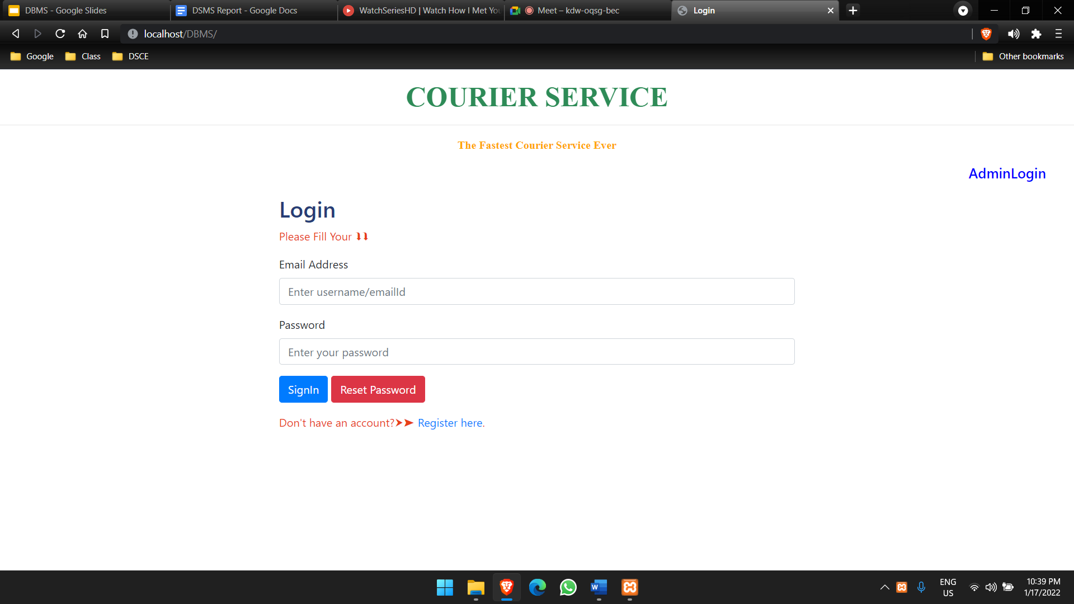

**11.1 Login page**

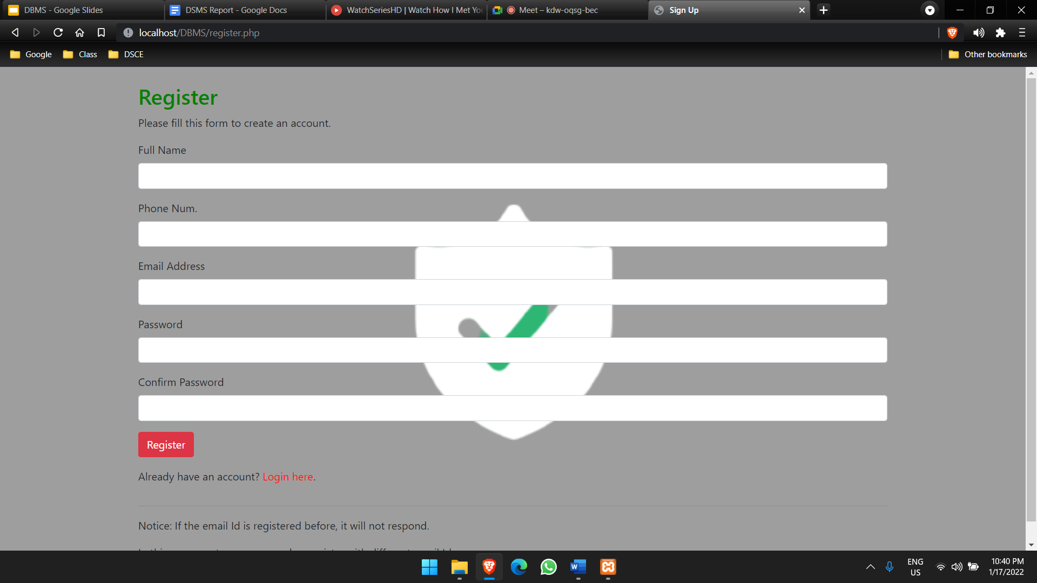

**11.2 Sign Page**

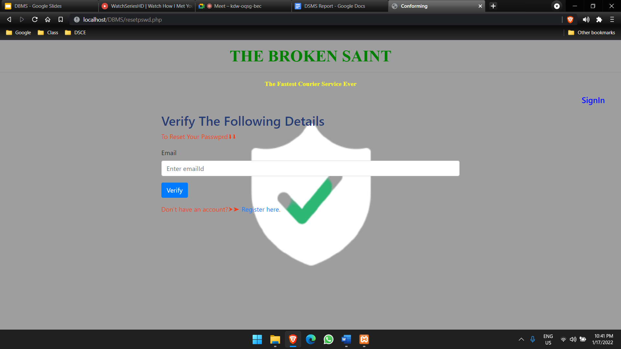

**11.3 Reset Password**

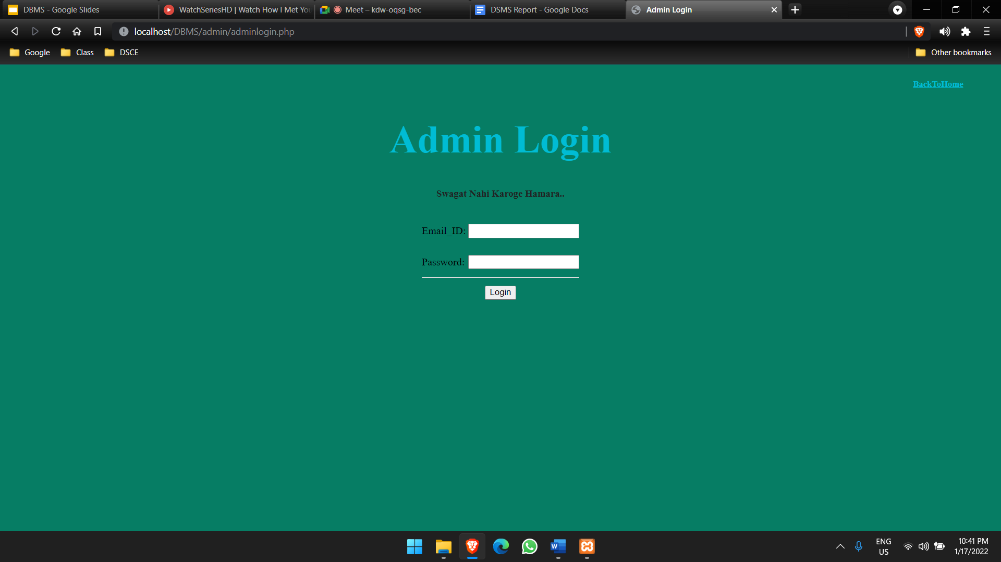

**11.4 Admin Login**

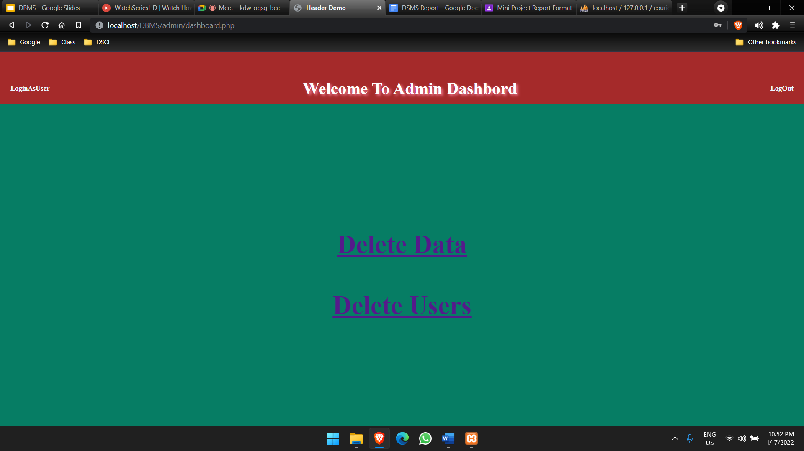

**11.5 Admin Page**

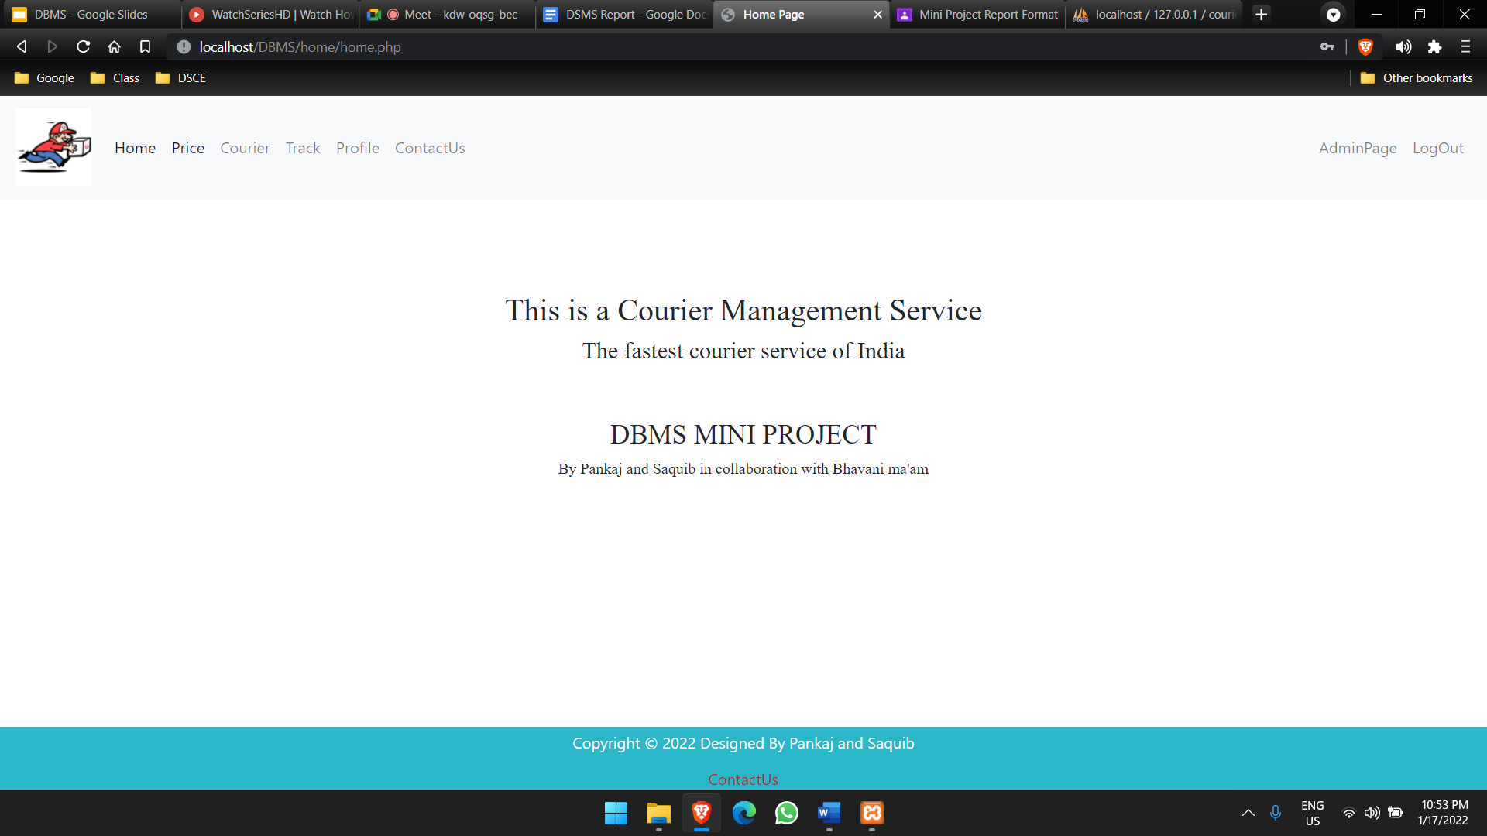

**11.6 Home Page**

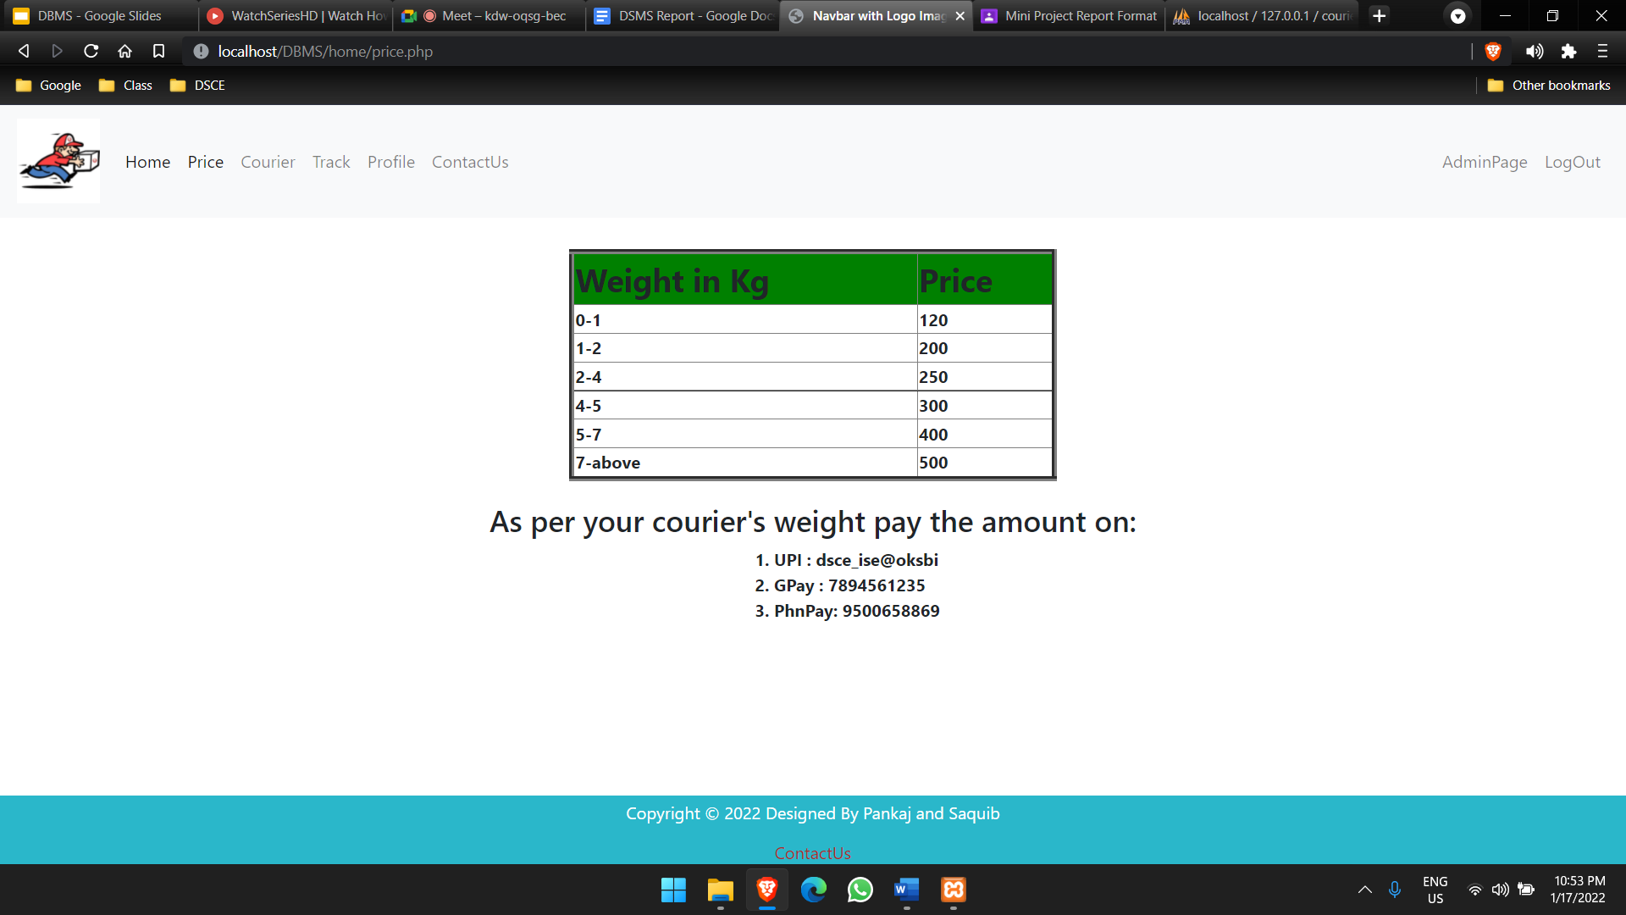

**11.7 Price Page**

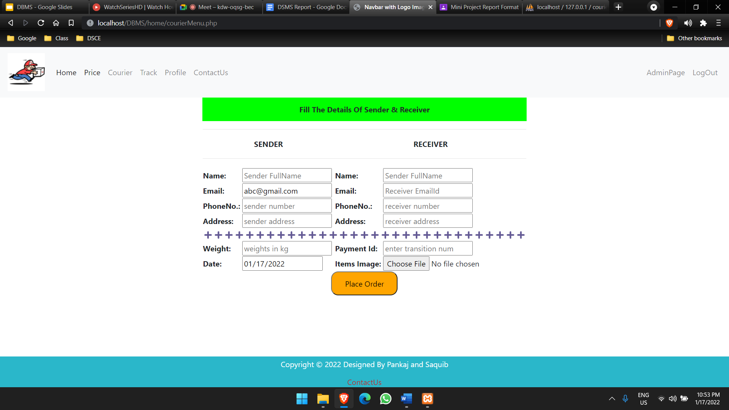

**11.8 Courier Page**

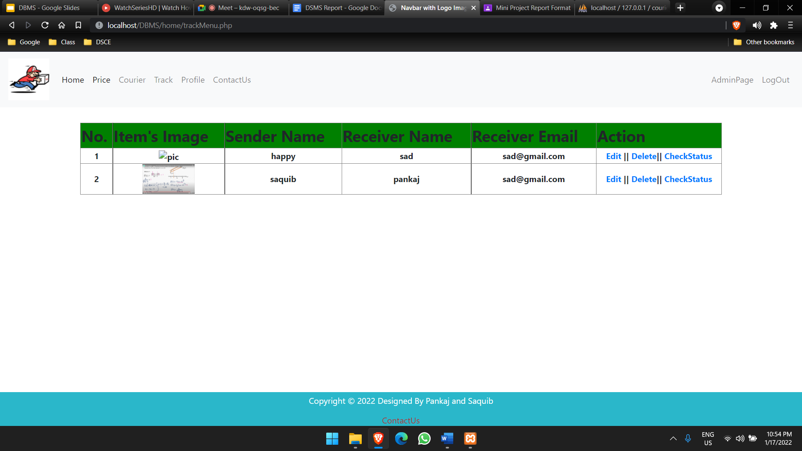

**11.9 Track Page**

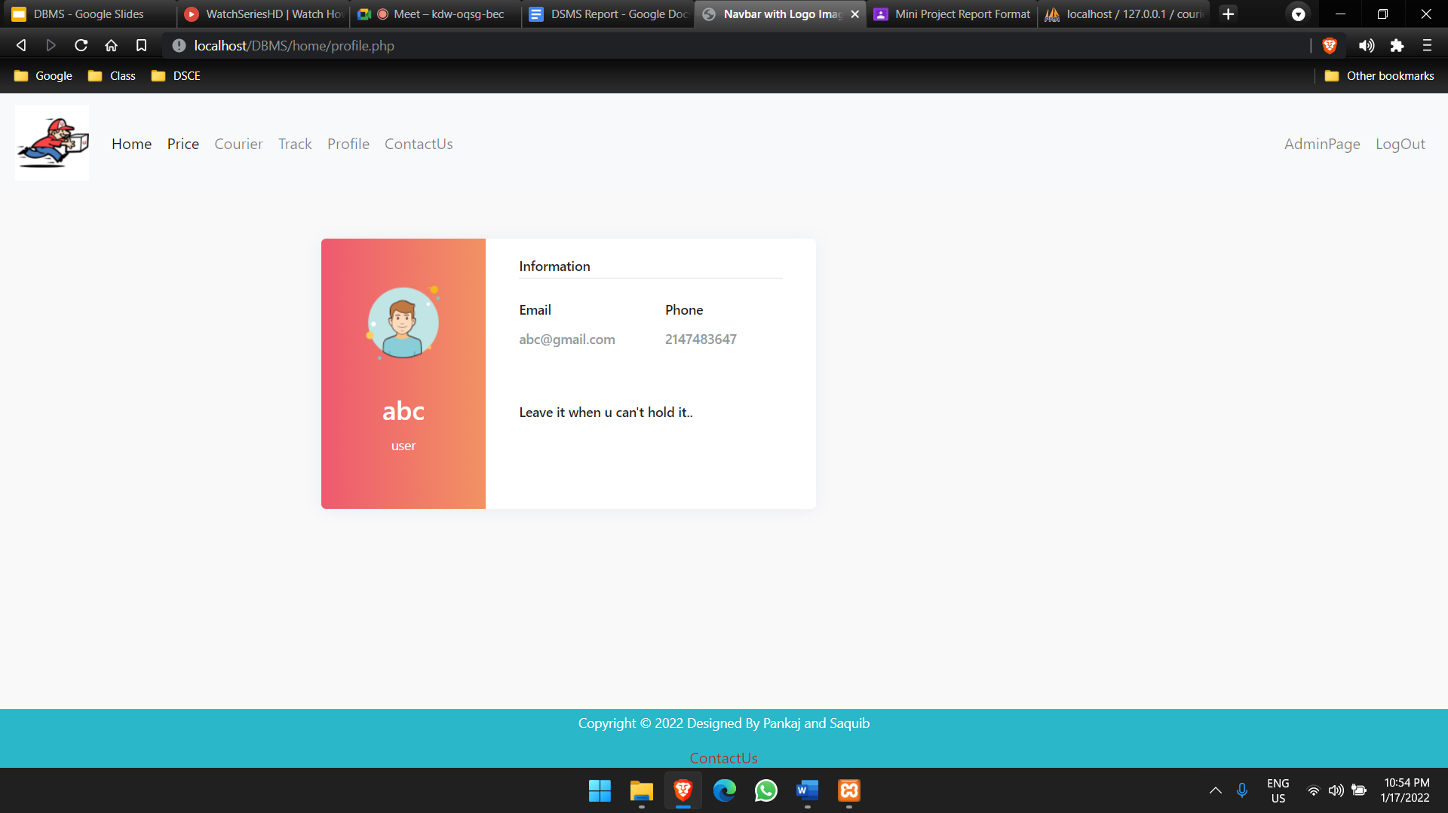

**11.10 Profile Page**

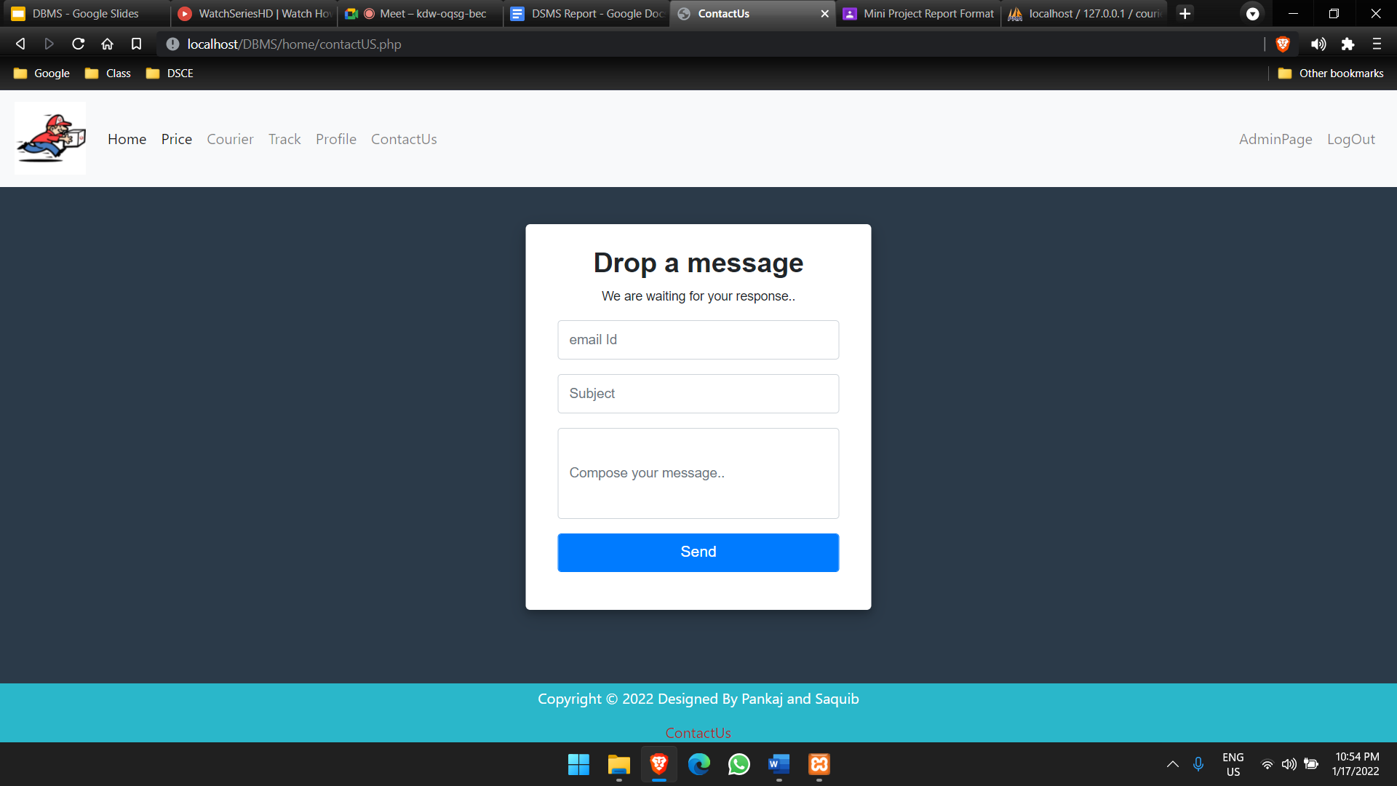

**11.11 Contact Page**

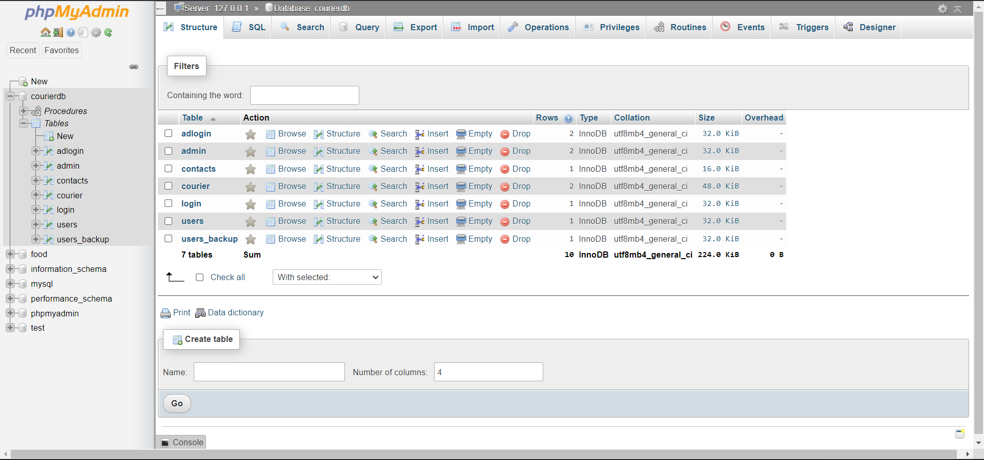

**11.12 Tables in Database**

**Chapter 12**

**Conclusion**

**12.1 Conclusion**

System development is also considered as a process backed by engineering approach. We have tried to incorporate & develop new particles for our education. Particles have been followed not during coding but also during the analysis, design phases & in documentation.

Courier agency is considered as an expansion of business relations. It contributes a lot by providing quick & fast services of sending documents, letters (formal & informal both) to business as it enables any business to flourish.

**12.2 Future scope**

Following modification or upgrades can be done in the system.

1) More than one company can be integrated through this software.

2) Web services can be used to know the exact delivery status of packets.

3) Clients can check the repacked delivery status online.

4) Distributed database approach in place of centralized approach

**12.3 Report Generation**

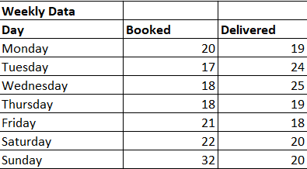

**12.3.1 Weekly data**

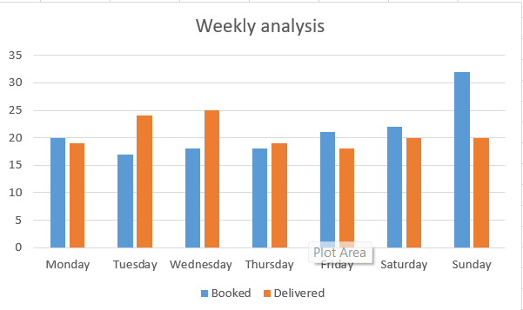

**12.3.2 Weekly Graph**

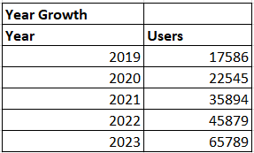

**12.3.3 Expected Growth**

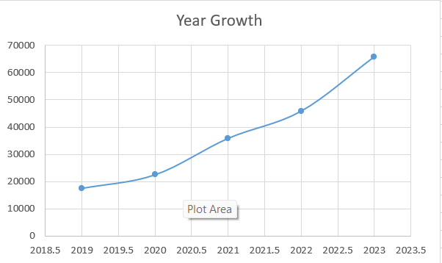

**12.3.4 Expected Growth Graph**

**Chapter 13**

**References**

#### **13.1 BOOK REFERENCE**

* Database System Models, Languages, Ramez Elmasri and ShamKant B. Navathe, 7thEdition, 2017 Pearson.
* Fundamentals of Web Development, Randy Connolly and Ricardo Hoar ,First Impression, 2016 Pearson

**13.2 Website**

* http://www.bluedart.com/
* http://www.xamppserver.com/en/
* http://www.php.net/
* http://youtube.com/
* http://www.tutorialspoint.com/mysql/
* https//apache.org/docs/2.0/misc/tutorials.html
* w ww.google.com
* h ttps://[www.w3schools.com](http://www.w3schools.com/)